**LAPORAN PENGERJAAN**

**UJI KOMPENTENSU KEJURUAN**

Disusun untuk Memenuhi Sebagian Persyaratan Kenaikan Kelas

Tahun Pelajaran 2022/2023



**Disusun oleh : DWIKI**

**NUGRAHA**

**NIS.2122.10.362**

**PROGRAM KEAHLIAN REKAYASA PERANGKAT LUNAK**

**SMK MAHARDHIKA BATUJAJAR 2024**

**LAPORAN PENGERJAAN UJI KOMPETENSI KEJURUAN**

**SMK MAHARDHIKA BATUJAJAR**

**TAHUN PELAJARAN 2022-2023**

KOMPETENSI KEAHLIAN : Rekayasa Perangkat Lunak

KELAS : XII RPL I

NAMA LENGKAP : Dwiki Nugraha

NIS : 3

PAKET SOAL : 3

JENIS APLIKASI : Web

ALOKASI WAKTU : 24 jam

# 1. PENJADWALAN KEGIATAN



# 2. PERSIAPAN PERANGKAT KERAS

|  |  |
| --- | --- |
| **Device name DESKTOP-Q4I1NEE**  Processor Intel(R) Core(TM) i5-3470 CPU @ 3.20GHz 3.60 GHz  Installed RAM 8,00 GB  Device ID F1050367-B73D-4033-B0D4-F3CE686583D2  Product ID 00331-10000-00001-AA844  System type Sistem operasi 64-bit, prosesor berbasis x64  Pen and touch No pen or touch input is available for this display | **Edition Windows 10 Pro**  Version : 22H2  Installed on : ‎26/‎03/‎2023  OS build : 19045.3803  Experience : Windows Feature Experience Pack : 1000.19053.1000.0 |

# 3. PERSIAPAN PERANGKAT LUNAK

-Astah

- Balsamiq

- Xampp control panel

- visual studio code

- chorome

# 4. PERANCANGAN ALGORITMA APLIKASI

a. Activty diagram

* Activty diagram login

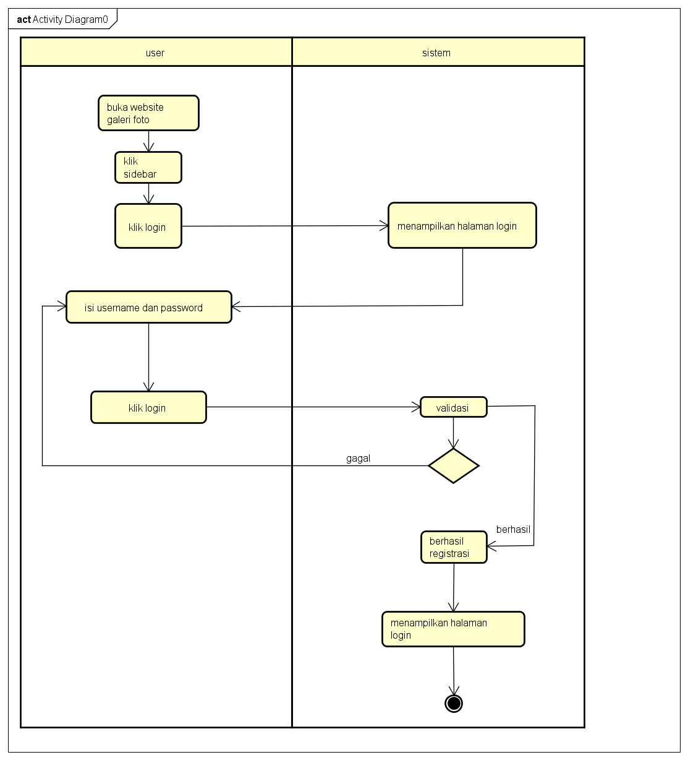

* Activty diagram daftar

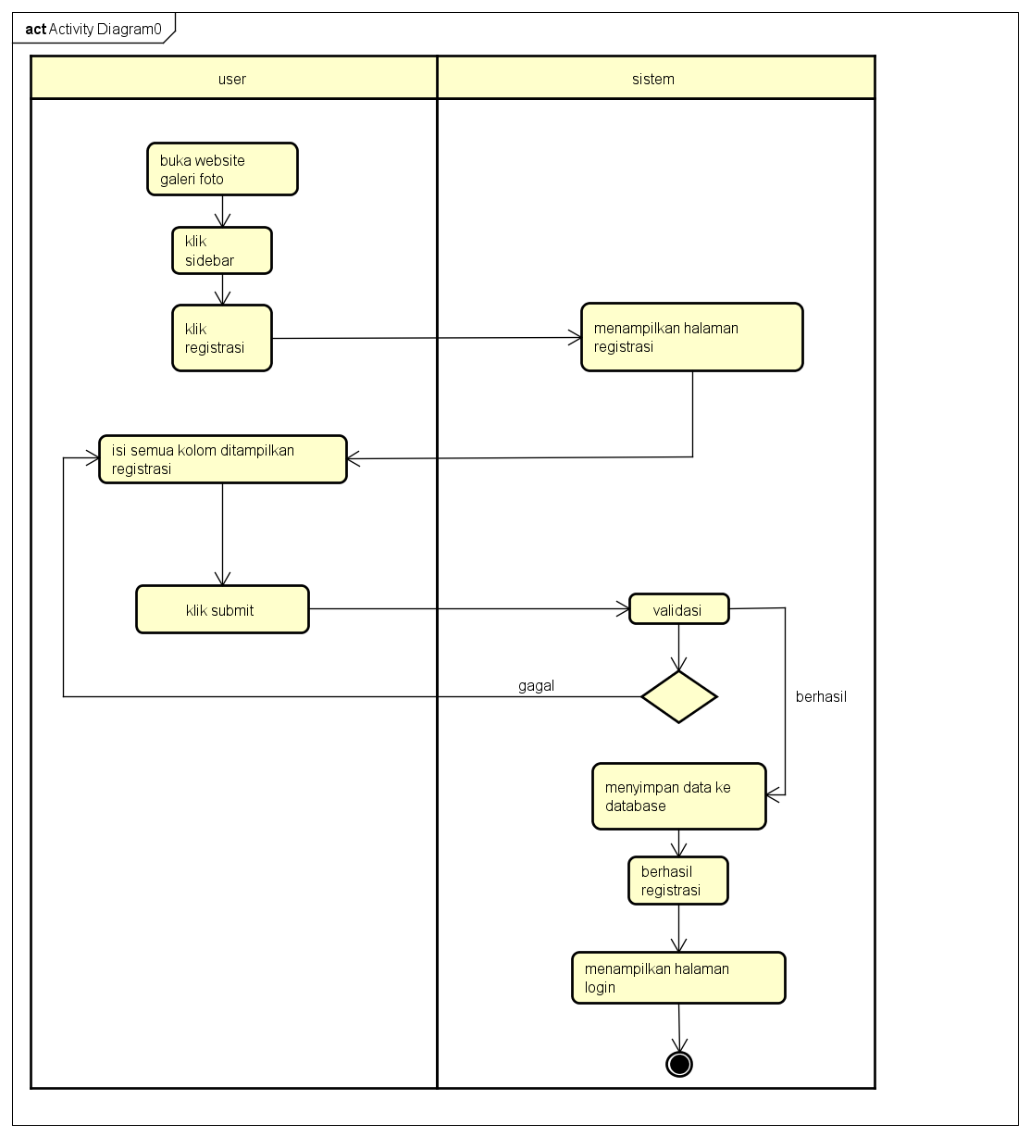

* Activity diagram tambah foto

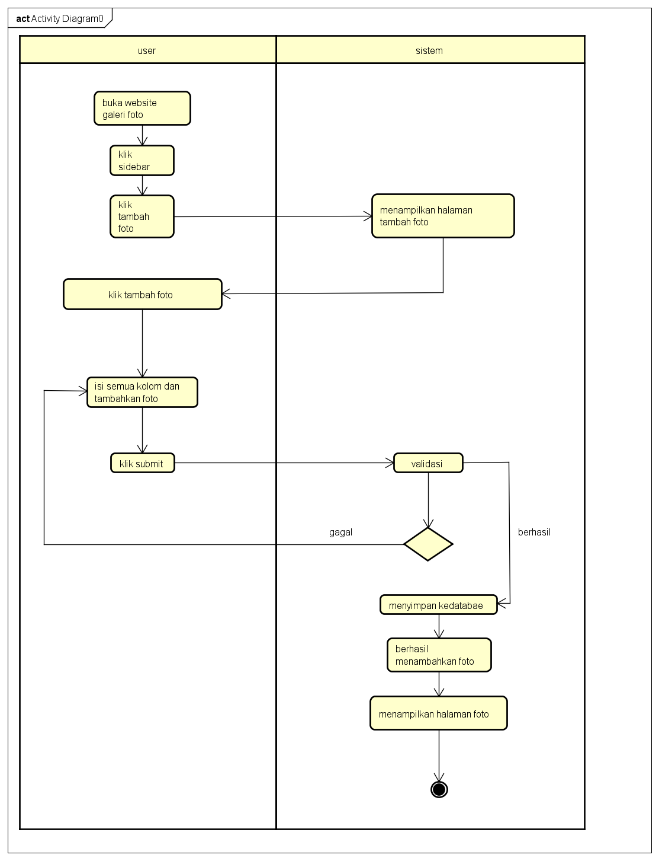

* Activity diagram edit data foto

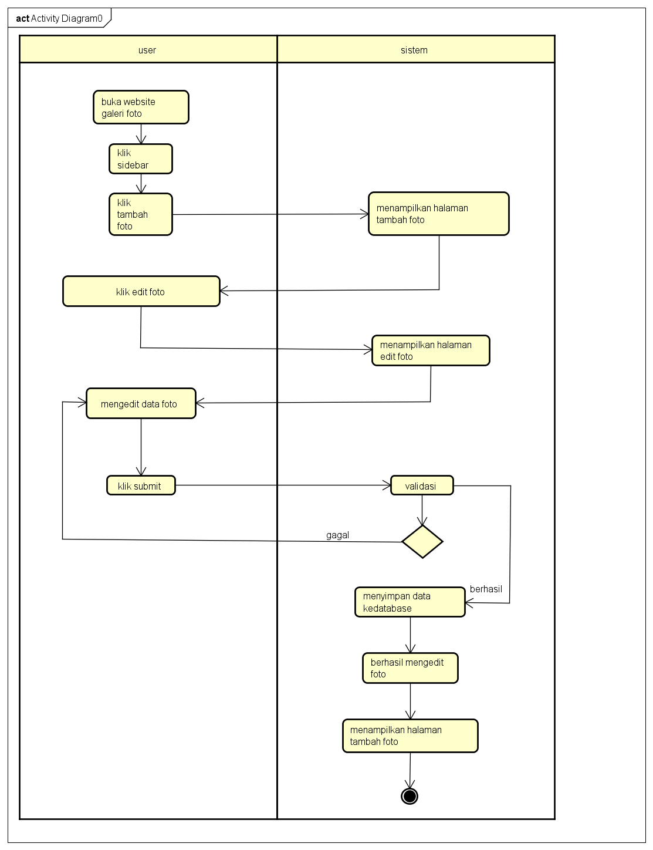

* Activity diagram hapus foto

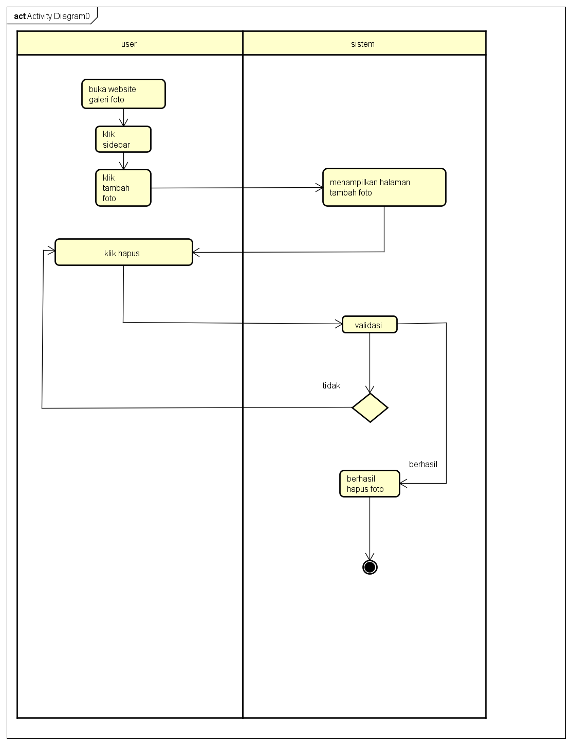

* Aktivity diagram log out

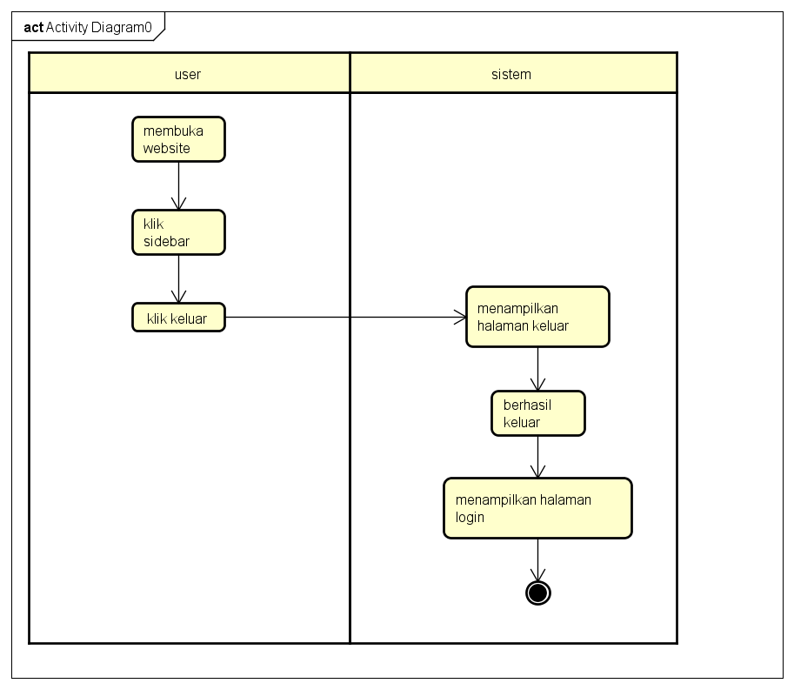

* Aktivity diagram galeri

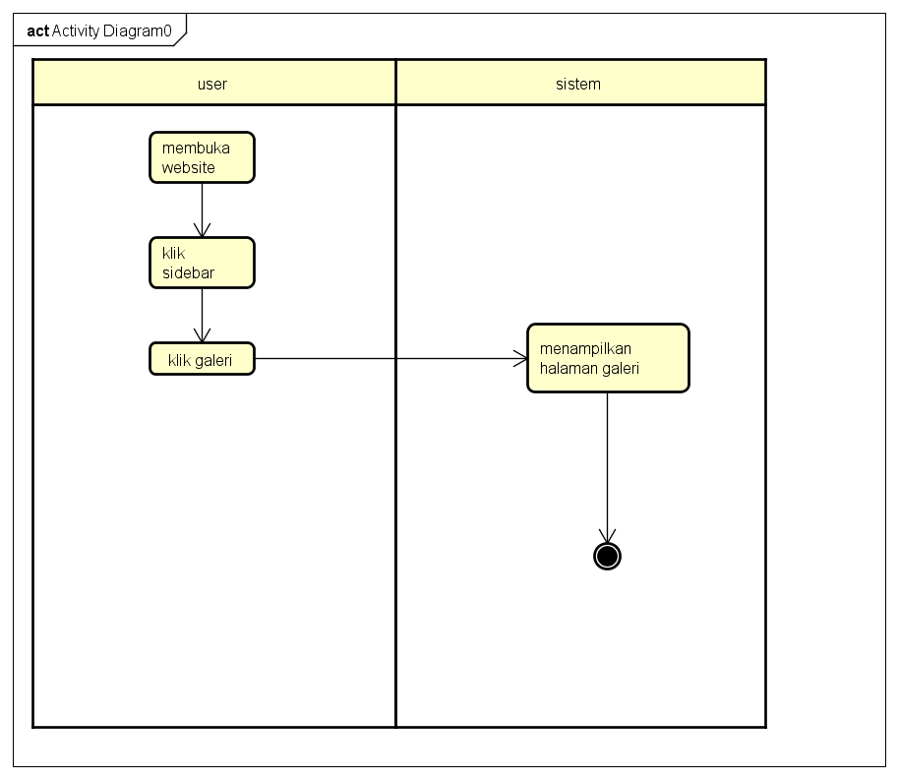

# 5. PERANCANGAN DESAIN BASIS DATA

*Silahkan gambarkan ERD/DFD/class diagram atau desain basis data pada phpMyAdmin beserta relasinya*

* 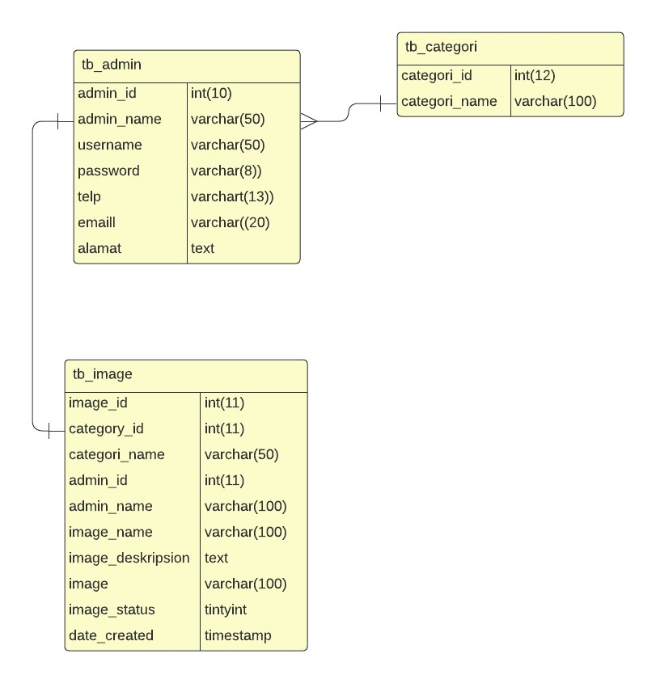Class diagram

* 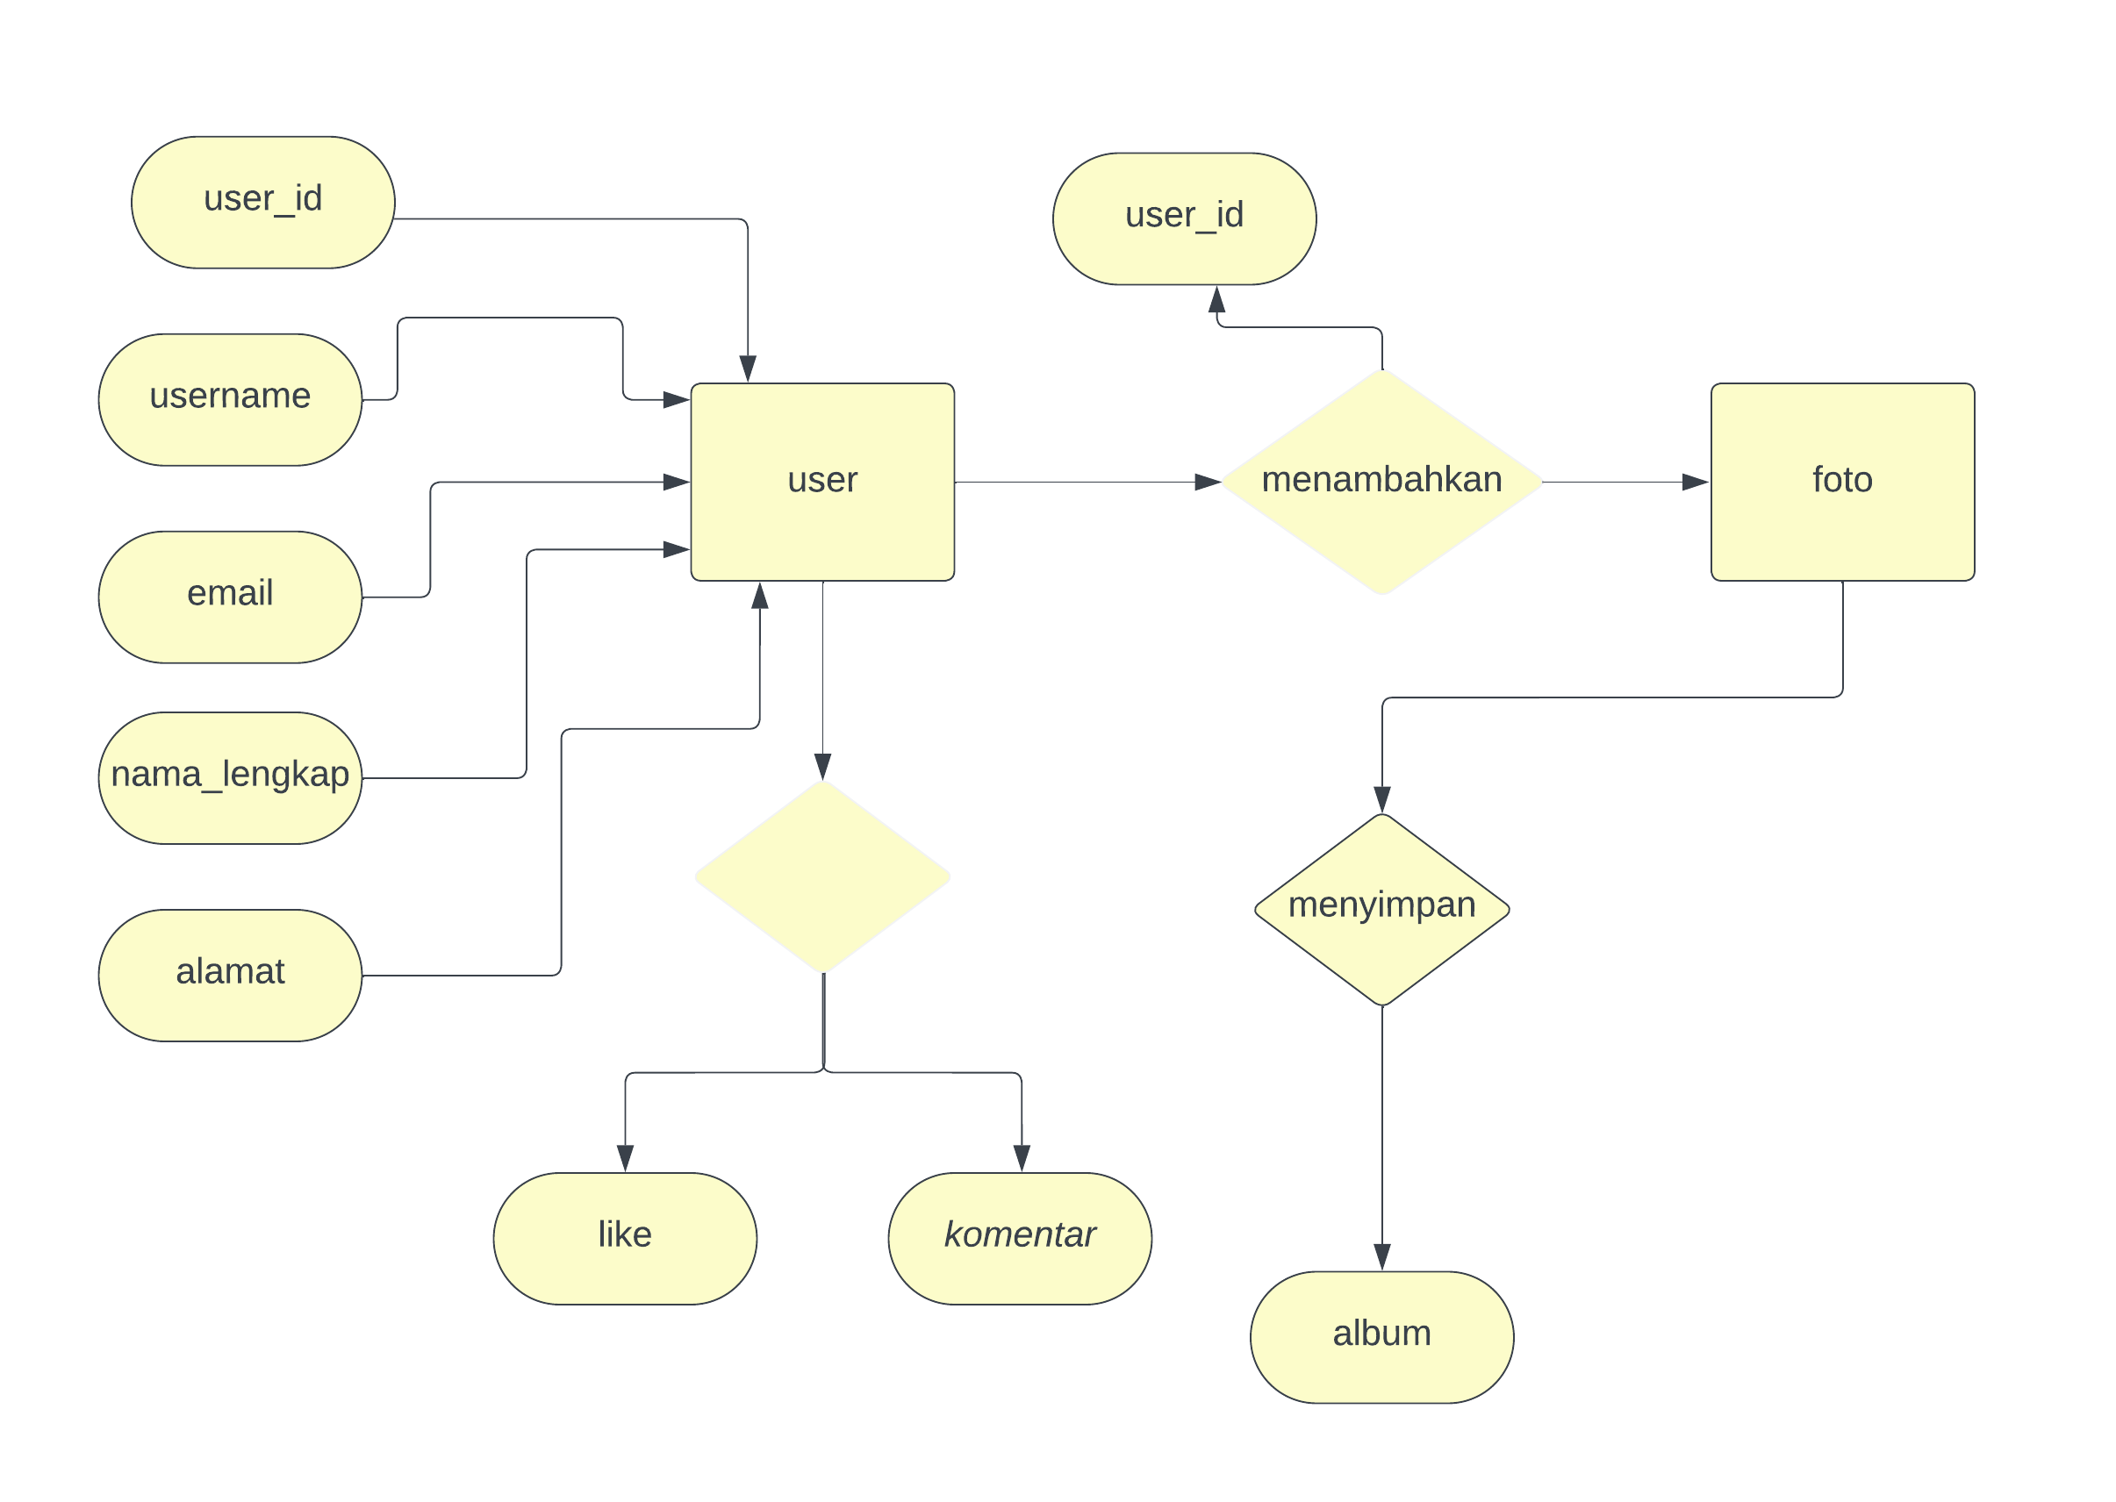ERD

# 6. DUMMY DATA

* User

|  |  |  |  |  |  |
| --- | --- | --- | --- | --- | --- |
| Nama user | Username | Password | Nomor hp | Email | Alamat |
| Dwiki | Ki Tea | 123321 | 081537034917 | [kitea@gmail.com](mailto:kitea@gmail.com) | Sekeloa |
| Raufli | Apong | 099099 | 081346521467 | [apong@gmail.com](mailto:apong@gmail.com) | galanggan |
| Iqbal | Pur | 988912 | 051460318131 | [pur@gmail.com](mailto:pur@gmail.com) | Cibeber |
| Rizki | Kiw | 176271 | 081541562454 | [kyy@gmail.com](mailto:kyy@gmail.com) | Citapen |
| Rangga | Wid | 67d6aj | 085451526934 | [gaa@gmail.com](mailto:gaa@gmail.com) | bbj |

* galeri

|  |  |  |  |  |  |  |  |  |
| --- | --- | --- | --- | --- | --- | --- | --- | --- |
| Id foto | Kategori id | Nama kategori | User_id | Nama foto | Deskripsi foto | foto | Image status | Tanggal dibuat |
| 1 | 14 | pemandangan | 1 | gabrut | . | Png.30321 | aktif | 19-02-2024 |
| 2 | 15 | arsitektur | 4 | prosedur | waw | Jpeg.32032 | Tidak aktif | 20-02-2024 |

* kategori

# 7. PEMBUATAN BASIS DATA (MySQL Code)

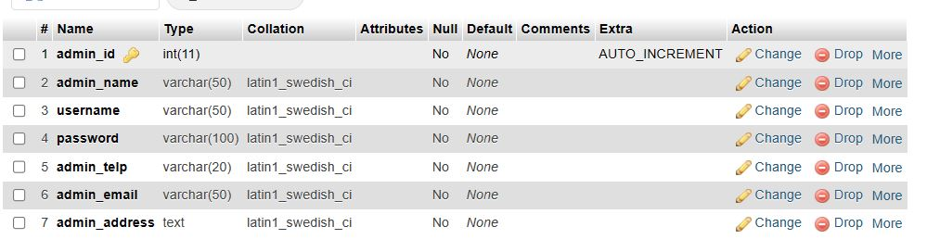

* Database admin/user
* Database kategori

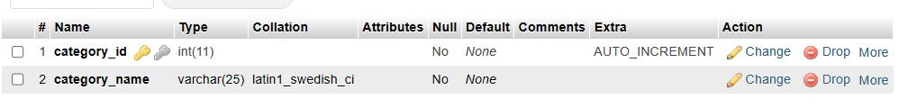

* Database Image

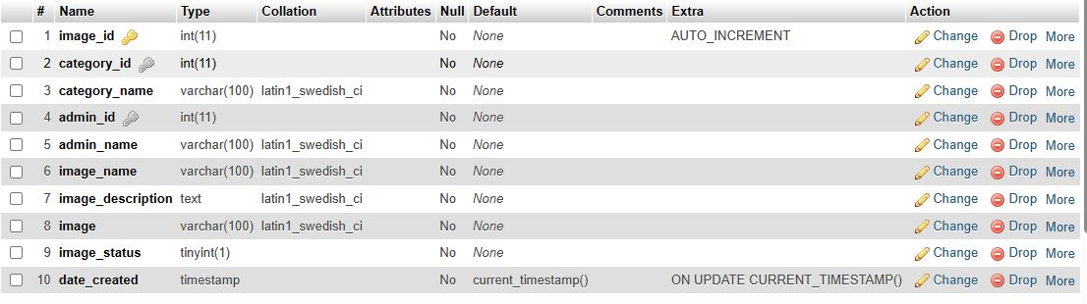

# 8. PERANCANGAN TAMPILAN ANTARMUKA (UI) WEB

* **website galeri foto**

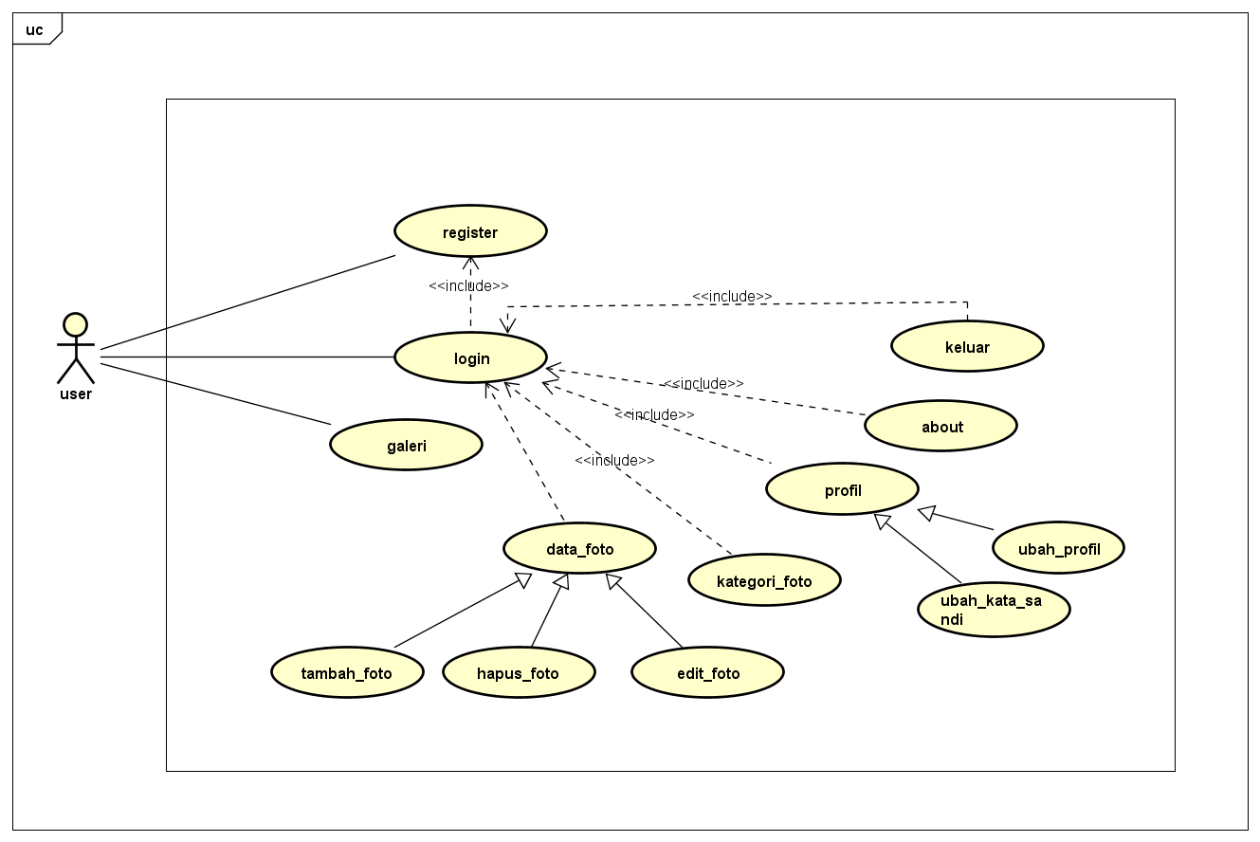

* **Tampilan awal web**

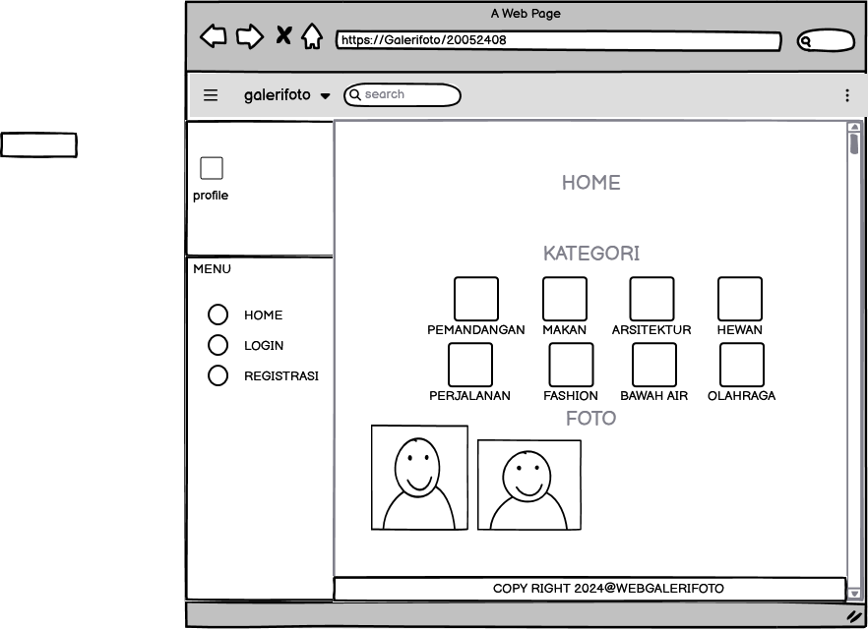

* **Registasi**

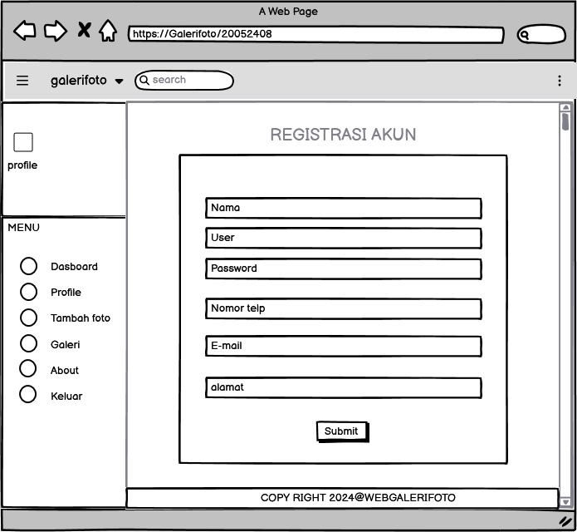

* **Login**

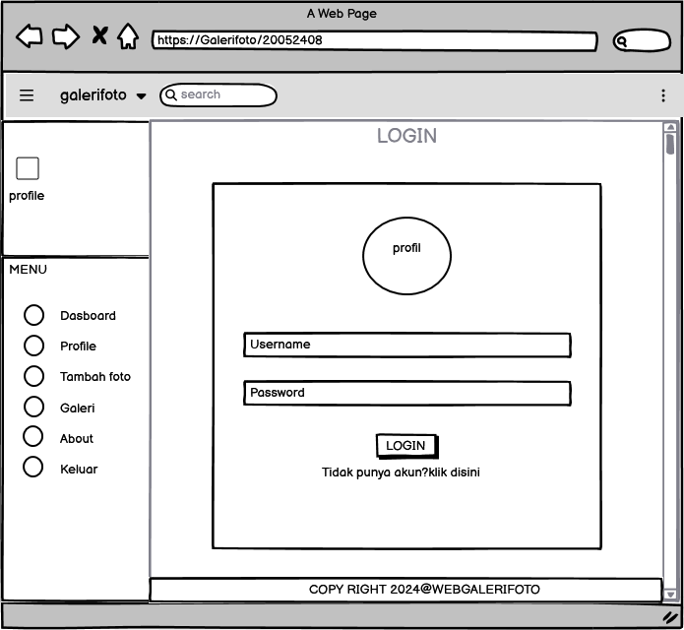

* **Dashboard**

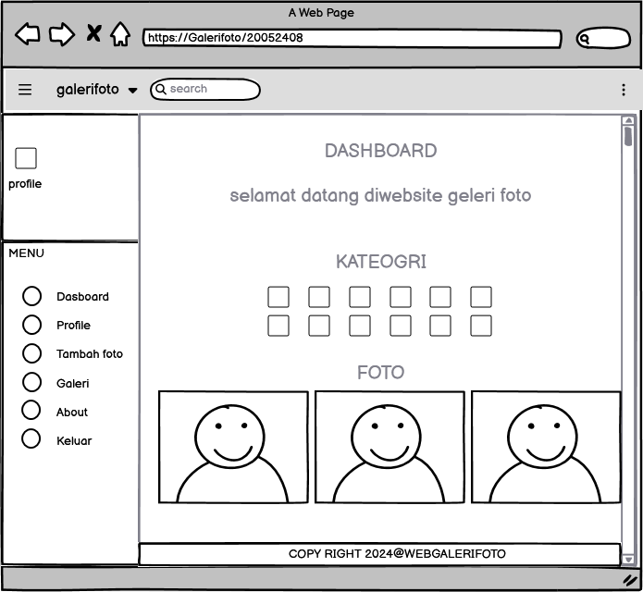

* **Profil**

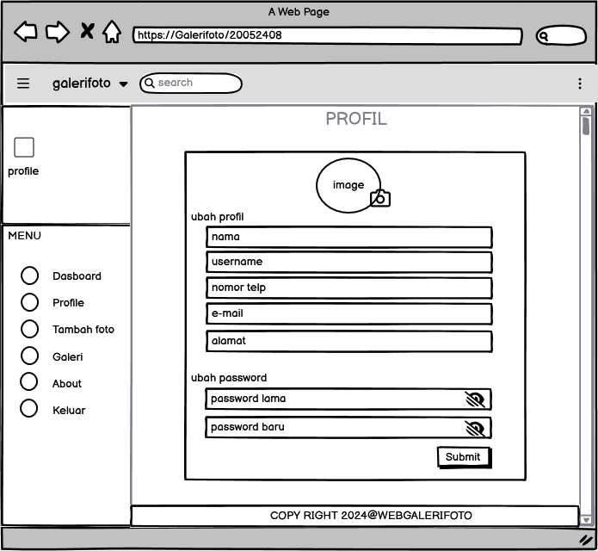

* **Tambah foto**

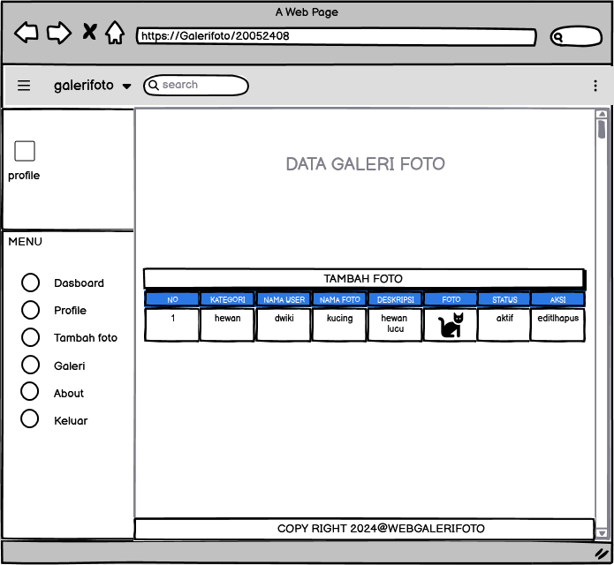

* **Galeri foto**

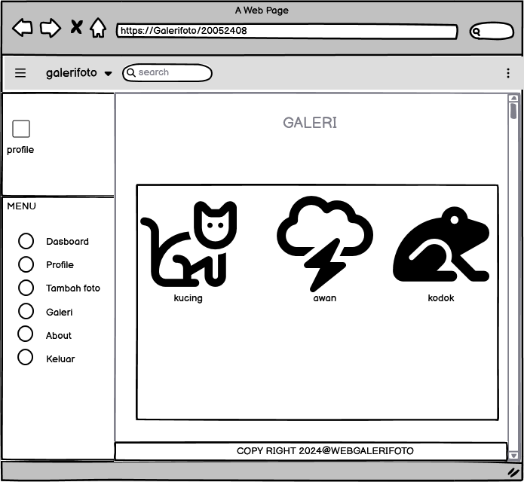

* **About**

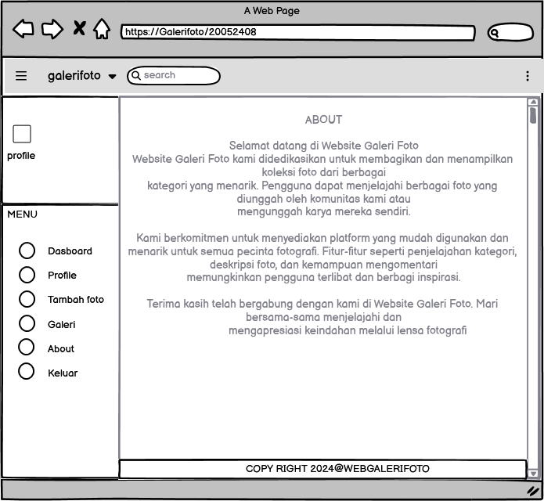

* **Log out/keluar**

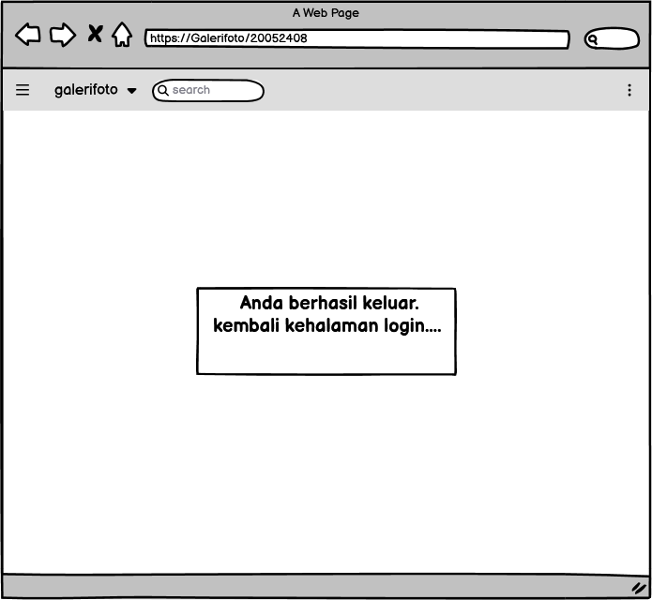

# 9. PEMBUATAN STRUKTUR WEB (HTML)

|  |
| --- |
| <!DOCTYPE html PUBLIC "-//W3C//DTD XHTML 1.0 Transitional//EN" "http://www.w3.org/TR/xhtml1/DTD/xhtml1-transitional.dtd">  <html xmlns="http://www.w3.org/1999/xhtml">  <head>  <meta charset="utf-8">  <meta name="viewport" content="width=device-width, initial-scale=1">  <title>WEB Galeri Foto</title>  <link rel="stylesheet" href="https://fontawesome.com/icons"/>  <link rel="stylesheet" type="text/css" href="css/stylee.css">  </head>  <body>  <!-- header -->  <header>  <div class="condebar">  <div class="overlay" onclick="closeSidebar()"></div>  <aside class="sidebar" id="sidebar">  <!-- Sidebar Content Here -->  <header>  <span onclick="closeSidebar()"></span>  <div class="title">  <img src="img/logo-dwiki.png" alt="Logo" class="logo">  </div>  </header>  <ul class="links">  <li><a href="index.php">Home</a></li>  <li><a href="login.php">Login</a></li>  <li><a href="registrasi.php">Registrasi</a></li>  <!-- Add more links as needed -->  </ul>  </aside>  <div class="main-content">  <button class="open-btn" onclick="toggleSidebar()">☰</button>  <!-- Main Content Goes Here -->  </div>  </div>  <script src="js.js"></script>  </body>  </html>  <div class="title">  <img src="img/logo-dwiki.png" alt="Logo" class="logo">  <h1>GALERI FOTO</h1>  </div>  </header>  <!--serche-->  <div class="search">  <div class="container">  <form action="galeri.php">  <input type="text" name="search" placeholder="Cari Foto" />  <input type="submit" name="cari" value="Cari Foto" />  </form>  </div>  </div>  <div class="lol">  </div>  <!-- category -->  <div class="section">  <div class="container">  <h3>Kategori</h3>  <div class="box">  </body>  </html> |

# 10. PEMBUATAN STYLE WEB (CSS)

|  |
| --- |
| @charset "utf-8";  /* CSS Document */  * {  padding:0;  margin:0;  font-family:'Quicksand', sans-serif;  }  body {  font-family: 'Arial', sans-serif;  background-color: #f5f5f5;  color: #333;  margin: 0;  padding: 0;  }  /* Your existing styles here */  .condebar{  display: flex;  }    .overlay {  display: none;  position: fixed;  top: 0;  left: 0;  width: 100%;  height: 100%;  background: rgba(0, 0, 0, 0.5);  }    .sidebar {  position: fixed;  width: 240px;  height: 100%;  background: #1e1e1e;  top: 0;  left: -240px;  transition: left 0.3s ease;  }    .sidebar header {  font-size: 28px;  color: white;  line-height: 70px;  text-align: center;  background: #1b1b1b;  user-select: none;  font-family: 'Montserrat', sans-serif;  cursor: pointer;  }    .sidebar a {  display: block;  height: 65px;  width: 100%;  color: white;  line-height: 65px;  padding-left: 30px;  box-sizing: border-box;  border-bottom: 1px solid black;  border-top: 1px solid rgba(255, 255, 255, .1);  border-left: 5px solid transparent;  font-family: 'Open Sans', sans-serif;  transition: all .5s ease;  }    .sidebar a i {  font-size: 23px;  margin-right: 16px;  }    .logo img {  width: 50px; /* Adjust as needed */  }    .links {  list-style: none;  padding: 0;  }    .links li {  margin-bottom: 10px;  }    .links a {  text-decoration: none;  color: #fff;  display: block;  padding: 8px;  border-radius: 4px;  transition: background-color 0.3s ease;  }    .links a:hover {  background-color: #000000;  }    .logout-link {  margin-top: 20px;  }    .main-content {  flex: 1;  padding: 20px;  box-sizing: border-box;  /* Add any additional styling for your main content */  }    .open-btn {  position: fixed;  top: 10px;  left: 10px;  background-color: #333;  color: white;  border: none;  padding: 10px;  cursor: pointer;  font-size: 16px;  }      .post {  background-color: #fff;  border: 1px solid #ccc;  margin: 20px auto;  max-width: 600px;  padding: 20px;  box-sizing: border-box;  }  .actions {  display: flex;  justify-content: space-between;  margin-top: 10px;  }  .like-comment {  display: flex;  align-items: center;  }  .like-btn.liked {  color: #ff5050; /* Liked color */  }  .like-btn, .comment-btn {  font-size: 20px;  cursor: pointer;  border: none;  background: none;  }  .like-btn {  background-color: #ce0b0b;  color: #fff;  border: none;  }  .like-btn {  background-color: #ffffff;  color: #fff;  border: none;  }  .comments {  margin-top: 20px;  }  .comment {  margin-bottom: 10px;  }  .deskripsi {  background-color: #fff;  border: 1px solid #ccc;  padding: 20px;  margin: 20px auto;  max-width: 600px;  box-sizing: border-box;  border-radius: 8px;  box-shadow: 0 2px 4px rgba(0, 0, 0, 0.1);  }  .deskripsi h3 {  margin-bottom: 5px;  font-size: 1.5em;  }  .deskripsi h4 {  margin-bottom: 10px;  color: #555;  }  .user-info p {  margin: 0;  color: #555;  }  .description {  margin-top: 15px;  border-top: 1px solid #eee;  padding-top: 15px;  }  .description p {  margin: 0;  color: #333;  line-height: 1.5;  }  .box {  background-color: #fff;  border: 1px solid #ccc;  padding: 15px;  box-sizing: border-box;  margin: 10px 0 25px 0;  }  a {  color: inherit;  text-decoration:none;  }  #bg-login {  display: flex;  height: 100vh;  justify-content: center;  align-items: center;  }  .box-login {  width: 300px;  min-height: 200px;  border: 1px solid #ccc;  background-color: #fff;  padding: 15px;  box-sizing: border-box;  margin-left: auto;  margin-right: auto;  margin-top: 50px; /* Menambahkan margin atas agar berada di tengah vertikal */  }  .title {  display: flex;  flex-direction: column; /* Tampilkan elemen dalam kolom */  justify-content: center;  align-items: center;  height: auto;  margin: 20px 0;  text-align: center;  color: #333; /* Warna teks yang sesuai */  }  .title h1 {  font-size: 3em; /* Ukuran font lebih besar */  margin-bottom: 10px; /* Jarak bawah antara judul dan elemen berikutnya */  font-weight: bold; /* Tulisan tebal */  color: #080808; /* Warna teks judul yang menarik */  }  .title p {  font-size: 1.2em; /* Ukuran font untuk paragraf */  line-height: 1.; /* Tinggi baris yang nyaman */  }  .title a {  color: #0f0f0f; /* Warna teks untuk tautan */  text-decoration: none; /* Menghilangkan garis bawah tautan */  transition: color 0.3s ease; /* Efek transisi warna saat dihover */  }  .title a:hover {  color: #111213; /* Warna teks saat dihover */  }  .logo{  width: 50px; /* Sesuaikan lebar logo sesuai kebutuhan */  margin-right: 10px; /* Sesuaikan jarak antara logo dan teks */  }  .pemisah{  border: none;  border-top: 2px solid #4985ca;  width: 100%; /* Sesuaikan panjang garis (dalam contoh ini, 50% dari lebar container) */  margin-top: 10px; /* Sesuaikan jarak antara teks dan garis */  }  .button {  background-color: #000000;  color: #fff;  }  .box-login h2 {  text-align:center;  margin-bottom:15px;  }  .input-control {  width:100%;  padding:10px;  margin-bottom:15px;  box-sizing:border-box;  }  .btn {  padding: 8px 15px;  background-color: #2a72f8;  color: #fff;  border: none;  cursor: pointer;  display: block;  margin-left: auto;  margin-right: auto;  }    header {  background-color: #000000;  color: #fff;  padding: 10px 0;  text-align: center;  }  header h1 {  margin: 0;  }  ul {  list-style: none;  padding: 0;  }  ul li {  display: inline;  margin-right: 20px;  }  header ul li a {  padding:20px 0 20px 15px;  display: inline-block;  }  footer {  padding:25px 0;  }  .container {  width: 80%;  margin: 0 auto;  }  .container:after {  content:'';  display: block;  clear:both;  }  .section {  padding: 20px 0;  text-align: center;  }  .box {  background-color: #fff;  border:1px solid #ccc;  padding:15px;  box-sizing: border-box;  margin:10px 0 25px 0;  }  .box:after {  content: '';  display: block;  clear: both;  }  .table {  width: 100%;  border-collapse: collapse;  }  .table tr {  height: 30px;  }  .table tr td {  padding:5px 10px;  }  .search {  background-color: #ffffff;  padding: 5px; /* Menambahkan padding untuk memberikan ruang di sekitar elemen */  text-align: center;  border-radius: 8px; /* Memberikan sudut lengkung pada elemen */    }  .search input[type="text"] {  padding: 10px;  border: none;  border-radius: 4px;  }  .search input[type="submit"] {  padding: 10px 20px;  background-color: #080808;  color: #fff;  cursor: pointer;  border: none;  border-radius: 4px;  transition: background-color 0.3s ease; /* Efek transisi warna latar belakang saat hover */  }  .search input[type="submit"]:hover {  background-color: #111010 /* Warna latar belakang saat hover */  }  .lol {  padding: 5px;  text-align: right;  }  .lol a {  font-weight: bold;  text-decoration: none; /* Menghilangkan underline pada link */  color: #333; /* Warna teks yang sesuai */  transition: color 0.3s ease; /* Efek transisi warna ketika dihover */  }  .lol a:hover {  color: #007bff; /* Warna teks ketika dihover */  }  .col-5 {  width:20%;  height:100px;  text-align: center;  float: left;  padding:10px;  box-sizing: border-box;  }  .col-4 {  width:25%;  height: 230px;  border:1px solid #ccc;  float: left;  padding:10px;  box-sizing: border-box;  margin-bottom: 10px;  }  .col-4:hover {  box-shadow: 0 0 3px #999;  }  .col-4 img {  width: 100%;  }  .col-4 .nama {  font-weight: bold;  color: #666;  margin-bottom: 5px;  }  .col-4 .admin {  font-weight: bold;  color: #FC3F81;  }  .footer {  padding:25px 0;  background-color: #333;  color: #fff;  text-align: center;  }  .footer p {  margin-bottom: 10px;  }  .footer small {  margin-top: 25px;  display: inline-block;  }  .col-2 {  flex: 1;  margin-right: 20px; /* Adjust margin as needed z*/  }  .col-2 img {  border:1px solid #f9f9f9;  padding:5px;  box-sizing: border-box;  }  .col-2 h3 {  margin-bottom: 10px;  }  .col-2 h4 {  color: #0e57df;  }  .col-2 p {  margin:15px 0;  text-align: justify;  line-height: 25px;  font-size: 14px;  }  @media screen and (max-width: 768px) {  .container {  width: 90%;  }  .col-5 {  width:50%;  margin-bottom: 10px;  }  .col-4 {  width:50%;  height: 300px;  }  .col-2 {  width:100%;  }    } |

# 11. PEMBUATAN KODE WEB (PHP/JS)

* index.php

|  |
| --- |
| <?php  include 'db.php';  $kontak = mysqli_query($conn, "SELECT admin_telp, admin_email, admin_address FROM tb_admin WHERE admin_id = 2");  $a = mysqli_fetch_object($kontak);  ?>  <!DOCTYPE html PUBLIC "-//W3C//DTD XHTML 1.0 Transitional//EN" "http://www.w3.org/TR/xhtml1/DTD/xhtml1-transitional.dtd">  <html xmlns="http://www.w3.org/1999/xhtml">  <head>  <meta charset="utf-8">  <meta name="viewport" content="width=device-width, initial-scale=1">  <title>WEB Galeri Foto</title>  <link rel="stylesheet" href="https://fontawesome.com/icons"/>  <link rel="stylesheet" type="text/css" href="css/stylee.css">  </head>  <body>  <!-- header -->  <header>  <div class="condebar">  <div class="overlay" onclick="closeSidebar()"></div>  <aside class="sidebar" id="sidebar">  <!-- Sidebar Content Here -->  <header>  <span onclick="closeSidebar()"></span>  <div class="title">  <img src="img/logo-dwiki.png" alt="Logo" class="logo">  </div>  </header>  <ul class="links">  <li><a href="index.php">Home</a></li>  <li><a href="login.php">Login</a></li>  <li><a href="registrasi.php">Registrasi</a></li>  <!-- Add more links as needed -->  </ul>  </aside>  <div class="main-content">  <button class="open-btn" onclick="toggleSidebar()">☰</button>  <!-- Main Content Goes Here -->  </div>  </div>  <script src="js.js"></script>  </body>  </html>  <div class="title">  <img src="img/logo-dwiki.png" alt="Logo" class="logo">  <h1>GALERI FOTO</h1>  </div>  </header>  <!--serche-->  <div class="search">  <div class="container">  <form action="galeri.php">  <input type="text" name="search" placeholder="Cari Foto" />  <input type="submit" name="cari" value="Cari Foto" />  </form>  </div>  </div>  <div class="lol">  </div>  <!-- category -->  <div class="section">  <div class="container">  <h3>Kategori</h3>  <div class="box">  <?php  include 'db.php';  $kategori = mysqli_query($conn, "SELECT * FROM tb_category ORDER BY category_id DESC");  if(mysqli_num_rows($kategori) > 0){  while($k = mysqli_fetch_array($kategori)){  ?>  <a href="galeri.php?kat=<?php echo $k['category_id'] ?>">  <div class="col-5">  <img src="img/icon.png" width="50px" style="margin-bottom:5px;" />  <p><?php echo $k['category_name'] ?></p>  </div>  </a>  <?php }}else{ ?>  <p>Kategori tidak ada</p>  <?php } ?>  </div>  </div>  </div>  <!-- new product -->  <div class="container">  <h3>Foto Terbaru</h3>  <div class="box">  <?php  $foto = mysqli_query($conn, "SELECT * FROM tb_image WHERE image_status = 1 ORDER BY image_id DESC LIMIT 8");  if(mysqli_num_rows($foto) > 0){  while($p = mysqli_fetch_array($foto)){  ?>  <a href="detail-image.php?id=<?php echo $p['image_id'] ?>">  <div class="col-4">  <img src="foto/<?php echo $p['image'] ?>" height="150px" />  <p class="nama"><?php echo substr($p['image_name'], 0, 30) ?></p>  <p class="admin">Nama User : <?php echo $p['admin_name'] ?></p>  <p class="nama"><?php echo $p['date_created'] ?></p>  </div>  </a>  <?php }}else{ ?>  <p>Foto tidak ada</p>  <?php } ?>  </div>  </div>    <!-- footer -->  <footer>  <div class="container">  <small>Copyright &copy; 2024 - Web Galeri Foto.</small>  </div>  </footer>  </body>  </html> |

* File koneksi.php

|  |
| --- |
| <?php  $hostname = 'localhost';  $username = 'root';  $password = '';  $dbname = 'galerifoto';    $conn = mysqli_connect($hostname, $username, $password, $dbname) or die ('gagal terhubung ke database');  ?> |

* Tambah foto

|  |
| --- |
| <?php  session_start();  include 'db.php';  if ($_SESSION['status_login'] != true) {  echo '<script>window.location="login.php"</script>';  }  ?>  <!DOCTYPE html>  <html lang="en">  <head>  <meta charset="UTF-8">  <meta name="viewport" content="width=device-width, initial-scale=1.0">  <title>WEB Galeri Foto - Tambah Data Foto</title>  <link rel="stylesheet" type="text/css" href="css/stylee.css">  <!-- Tambahkan stylesheet untuk CKEditor -->  <script src="https://cdn.ckeditor.com/4.16.2/standard/ckeditor.js"></script>  <style>  body {  font-family: Arial, sans-serif;  background-color: #f5f5f5;  margin: 0;  padding: 0;  }  header {  background-color: #2a72f8;  color: #fff;  padding: 15px 0;  text-align: center;  }  header h1 {  margin: 0;  }  .lol ul {  list-style: none;  padding: 0;  margin: 0;  }  .lol li {  display: inline-block;  margin-right: 20px;  }  .lol a {  text-decoration: none;  color: #fff;  font-weight: bold;  }  .section {  padding: 20px 0;  text-align: center;  }  .container {  width: 80%;  margin: 0 auto;  }  .box {  background-color: #fff;  border: 1px solid #ccc;  padding: 20px;  border-radius: 8px;  box-shadow: 0 2px 4px rgba(0, 0, 0, 0.1);  box-sizing: border-box;  margin-top: 20px;  }  .input-control {  width: 100%;  padding: 10px;  margin-bottom: 15px;  box-sizing: border-box;  }  .btn {  padding: 10px 15px;  background-color: #2a72f8;  color: #fff;  border: none;  cursor: pointer;  display: block;  margin-left: auto;  margin-right: auto;  }  footer {  padding: 25px 0;  background-color: #333;  color: #fff;  text-align: center;  }  footer p {  margin-bottom: 10px;  }  footer small {  margin-top: 25px;  display: inline-block;  }  </style>  </head>  <body>  <!-- header -->  <header>  <div class="condebar">  <div class="overlay" onclick="closeSidebar()"></div>  <aside class="sidebar" id="sidebar">  <!-- Sidebar Content Here -->  <header>  <span onclick="closeSidebar()"></span>  <div class="title">  <img src="img/logo-dwiki.png" alt="Logo" class="logo">  </div>  </header>  <ul class="links">  <li><a href="dashboard.php">Home</a></li>  <li><a href="profil.php">Profil</a></li>  <li><a href="data-image.php">tambah foto</a></li>  <li><a href="galeri.php">galeri</a></li>  <li><a href="about.php">about</a></li>  <li><a href="keluar.php">keluar</a></li>  <!-- Add more links as needed -->  </ul>  </aside>  <div class="main-content">  <button class="open-btn" onclick="toggleSidebar()">☰</button>  <!-- Main Content Goes Here -->  </div>  </div>  <script src="js.js"></script>  </div>  <div class="title">  <img src="img/logo-dwiki.png" alt="Logo" class="logo">  <h1>GALERI FOTO</h1>  </div>  </header>  <!-- content -->  <div class="section">  <div class="container">  <h3>Tambah Data Foto</h3>  <div class="box">  <form action="" method="POST" enctype="multipart/form-data">  <?php  $result = mysqli_query($conn, "SELECT * FROM tb_category");  $jsArray = "var prdName = new Array();\n";  echo '<select class="input-control" name="kategori" onchange="document.getElementById(\'prd_name\').value = prdName[this.value]" required>';  echo '<option>-Pilih Kategori Foto-</option>';  while ($row = mysqli_fetch_array($result)) {  echo '<option value="' . $row['category_id'] . '">' . $row['category_name'] . '</option>';  $jsArray .= "prdName['" . $row['category_id'] . "'] = '" . addslashes($row['category_name']) . "';\n";  }  echo '</select>';  ?>  <input type="hidden" name="nama_kategori" id="prd_name">  <input type="hidden" name="adminid" value="<?php echo $_SESSION['a_global']->admin_id ?>">  <input type="text" name="namaadmin" class="input-control" value="<?php echo $_SESSION['a_global']->admin_name ?>" readonly="readonly">  <input type="text" name="nama" class="input-control" placeholder="Nama Foto" required>  <textarea class="input-control" name="deskripsi" placeholder="Deskripsi"></textarea><br />  <input type="file" name="gambar" class="input-control" required>  <select class="input-control" name="status">  <option value="">--Pilih--</option>  <option value="1">Aktif</option>  <option value="0">Tidak Aktif</option>  </select>  <input type="submit" name="submit" value="Submit" class="btn">  </form>  <?php  if (isset($_POST['submit'])) {  $kategori = $_POST['kategori'];  $nama_ka = $_POST['nama_kategori'];  $ida = $_POST['adminid'];  $user = $_POST['namaadmin'];  $nama = $_POST['nama'];  $deskripsi = $_POST['deskripsi'];  $status = $_POST['status'];  $filename = $_FILES['gambar']['name'];  $tmp_name = $_FILES['gambar']['tmp_name'];  $type1 = explode('.', $filename);  $type2 = $type1[1];  $newname = 'foto' . time() . '.' . $type2;  $tipe_diizinkan = array('jpg', 'jpeg', 'png', 'gif');  if (!in_array($type2, $tipe_diizinkan)) {  echo '<script>alert("Format file tidak diizinkan")</script>';  } else {  move_uploaded_file($tmp_name, './foto/' . $newname);  $insert = mysqli_query($conn, "INSERT INTO tb_image VALUES (  null,  '" . $kategori . "',  '" . $nama_ka . "',  '" . $ida . "',  '" . $user . "',  '" . $nama . "',  '" . $deskripsi . "',  '" . $newname . "',  '" . $status . "',  null  ) ");  if ($insert) {  echo '<script>alert("Tambah Foto berhasil")</script>';  echo '<script>window.location="data-image.php"</script>';  } else {  echo 'gagal' . mysqli_error($conn);  }  }  }  ?>  </div>  </div>  </div>  <!-- footer -->  <footer>  <div class="container">  <small>Copyright &copy; 2024 - Web Galeri Foto.</small>  </div>  </footer>  <!-- Load CKEditor script -->  <script>  CKEDITOR.replace('deskripsi');  </script>  <!-- Load JavaScript for dynamic dropdown -->  <script type="text/javascript">  <?php echo $jsArray; ?>  </script>  </body>  </html> |

* Register

|  |
| --- |
| <?php  include 'db.php';  ?>  <!DOCTYPE html PUBLIC "-//W3C//DTD XHTML 1.0 Transitional//EN" "http://www.w3.org/TR/xhtml1/DTD/xhtml1-transitional.dtd">  <html xmlns="http://www.w3.org/1999/xhtml">  <head>  <meta charset="utf-8">  <meta name="viewport" content="width=device-width, initial-scale=1">  <title>WEB Galeri Foto</title>  <link rel="stylesheet" type="text/css" href="css/stylee.css">  </head>  <body>  <!-- header -->  <header>  <div class="condebar">  <div class="overlay" onclick="closeSidebar()"></div>  <aside class="sidebar" id="sidebar">  <!-- Sidebar Content Here -->  <header>  <span onclick="closeSidebar()"></span>  <div class="title">  <img src="img/logo-dwiki.png" alt="Logo" class="logo">  </div>  </header>  <ul class="links">  <li><a href="index.php">Home</a></li>  <li><a href="login.php">Login</a></li>  <li><a href="registrasi.php">Registrasi</a></li>  <!-- Add more links as needed -->  </ul>  </aside>  <div class="main-content">  <button class="open-btn" onclick="toggleSidebar()">☰</button>  <!-- Main Content Goes Here -->  </div>  </div>  <script src="js.js"></script>  </div>  <div class="title">  <img src="img/logo-dwiki.png" alt="Logo" class="logo">  <h1>GALERI FOTO</h1>  </div>  </header>    <!-- content -->  <div class="section">  <div class="container">  <h3>Registrasi Akun</h3>  <div class="box">  <form action="" method="POST">  <input type="text" name="nama" placeholder="Nama User" class="input-control" required>  <input type="text" name="user" placeholder="Username" class="input-control" required>  <input type="text" name="pass" placeholder="Password" class="input-control" required>  <input type="text" name="tlp" placeholder="Nomor Telpon" class="input-control" required>  <input type="text" name="email" placeholder="E-mail" class="input-control" required>  <input type="text" name="almt" placeholder="Alamat" class="input-control" required>  <input type="submit" name="submit" value="Submit" class="btn">  </form>  <?php  if(isset($_POST['submit'])){    $nama = ucwords($_POST['nama']);  $username = $_POST['user'];  $password = $_POST['pass'];  $telpon = $_POST['tlp'];  $mail = $_POST['email'];  $alamat = ucwords($_POST['almt']);    $insert = mysqli_query($conn, "INSERT INTO tb_admin VALUES (  null,  '".$nama."',  '".$username."',  '".$password."',  '".$telpon."',  '".$mail."',  '".$alamat."')    ");  if($insert){  echo '<script>alert("Registrasi berhasil")</script>';  echo '<script>window.location="login.php"</script>';  }else{  echo 'gagal '.mysqli_error($conn);  }    }  ?>  </div>    </div>  </div>  </div>  </div>    <!-- footer -->  <footer>  <div class="container">  <small>Copyright &copy; 2024 - Web Galeri Foto.</small>  </div>  </footer>  </body>  </html> |

* Hapus foto

|  |
| --- |
| <?php  include 'db.php';    if(isset($_GET['idp'])){  $foto = mysqli_query($conn, "SELECT image FROM tb_image WHERE image_id = '".$_GET['idp']."' ");  $p = mysqli_fetch_object($foto);    unlink('./foto/'.$p->image);    $delete = mysqli_query($conn, "DELETE FROM tb_image WHERE image_id = '".$_GET['idp']."' ");  echo '<script>window.location="data-image.php"</script>';  }  ?> |

# 12.UJI COBA

Skenario Use Case

Nama : Login

ID : UC01

Deskripsi : User mengakses login

Aktor : user

**Skenario utama**

|  |  |
| --- | --- |
| Aksi aktor | Reaksi sistem |
| 1. Membuka website dengan menggunakan domain localhost/galerifoto/index.php |  |
|  | 1. Menampilkan tampilan login |
| 1. Menambahkan username dan password |  |
| 1. Klik tombol login |  |
|  | 1. Berhasil login |
|  | 1. Menampilkan halaman dashboard |
| Skenario alternatif |  |
| 1. Menambahkan username dan password |  |
|  | 1. Menampilkan notifikasi “*password dan username anda salah*” |

Nama : Tambah

ID : UC02

Deskripsi : User menambahkan foto

Aktor : user

**Skenario utama**

|  |  |
| --- | --- |
| Aksi aktor | Reaksi sistem |
| 1. Melakukan login |  |
|  | 1. Menampilkan halaman dashboard dengan menu data foto dan galeri |
| 1. Klik menu data foto |  |
|  | 1. Menampilkan detail foto |
| 1. Klik tambah foto |  |
|  | 1. Menampilkan form tambah foto |
| 1. Menambahkan atau mengisi form data foto |  |
| 1. Klik tombol submit |  |
|  | 1. Menampilkan notifikasi “*tambah foto berhasil*” |

Nama : Hapus

ID : UC03

Deskripsi : User menghapus foto

Aktor : user

**Skenario utama**

|  |  |
| --- | --- |
| Aksi aktor | Reaksi sistem |
| 1. Melakukan login |  |
|  | 1. Menampilkan halaman dashboard dengan menu data foto dan galeri |
| 1. Klik menu data foto |  |
|  | 1. Menampilkan detail foto hapus dan edit |
| 1. Klik hapus foto |  |
|  | 1. Menampilkan notifikasi “*yakin ingin hapus*” |
| 1. Klik tombol “Ok” |  |
|  | 1. Berhasil menghapus foto |
|  |  |

Nama : Ubah

ID : UC04

Deskripsi : User mengubah data foto

Aktor : user

**Skenario utama**

|  |  |
| --- | --- |
| Aksi aktor | Reaksi sistem |
| 1. Melakukan login |  |
|  | 1. Menampilkan halaman dashboard dengan menu data foto dan galeri |
| 1. Klik menu data foto |  |
|  | 1. Menampilkan detail foto hapus dan edit |
| 1. Klik edit foto |  |
|  | 1. Menampilkan form edit data foto |
| 1. Edit data foto |  |
| 1. Klik tombol submit |  |
|  | 1. Menampilkan notifikasi “*berhasil ubah data foto*” |

Nama :

ID : UC05

Deskripsi : User mengubah data foto

Aktor : user

# 13.REVISI

# 14. PENENTUAN DOMAIN DAN HOSTING

# 15.UPLOAD WEB KE HOSTING

https://ujicobagaleri2.000webhostapp.com/

# 16. UPLOAD WEB KE GITHUB

https://github.com/dwikinugraha24/galerifoto.github.io.git

# 17. PEMBUATAN USER GUIDANCE